**SPACEX FALCON 9 FIRST STAGE LANDING SUCCESS PREDICTION**

1. **INTRODUCTION**

**1.1 Overview**

The project aimed to leverage the power of machine learning algorithms, SVM and linear regression, to develop a predictive model for Falcon 9 first stage landing. These algorithms were chosen for their ability to handle complex data patterns and make accurate predictions based on historical landing data. The project involved extensive data analysis and preprocessing to ensure the quality and relevance of the input data. Historical Falcon 9 landing data, including telemetry, environmental conditions, and other relevant variables, were collected and processed for training and testing the predictive model. To develop an effective predictive model, the project incorporated feature engineering techniques to identify and extract meaningful information from the available data. This involved selecting and transforming relevant variables to capture the crucial factors influencing the landing outcome. The machine learning models were trained using a suitable dataset, with a portion of the data reserved for evaluation purposes. Various evaluation metrics were employed to assess the performance and accuracy of the models in predicting the Falcon 9 first stage landing. The project included the development of a flowchart to illustrate the control flow of the predictive model. This diagram depicted the sequential steps involved in preprocessing the data, training the models, and utilizing them for prediction. The final findings of the project showcased the accuracy and effectiveness of the developed predictive model in determining the success of Falcon 9 first stage landings. The model's outputs and evaluation metrics provided evidence of its predictive capabilities and its potential to optimize landing precision. The project also discussed the advantages and disadvantages of the proposed solution. While the model offered enhanced accuracy and cost-effectiveness in predicting Falcon 9 first stage landings, it was acknowledged that unforeseen circumstances or anomalies during the landing process could pose challenges to the model's performance. The potential applications of the developed predictive model were explored, highlighting its relevance in the field of rocket systems. The model's capabilities could extend beyond Falcon 9 and be applied to other similar rocket platforms, supporting decision-making processes for recovery and reuse.

**1.2 Purpose**

The purpose of this project was to improve the precision and reliability of Falcon 9 first stage landings, leading to enhanced reusability and cost-efficiency of the rocket system. By developing a predictive model using machine learning algorithms such as SVM and Decision Tree regression, the project aimed to accurately forecast the outcome of Falcon 9 first stage landings. The ultimate goal was to optimize the landing precision, thereby increasing the success rate of landings and minimizing the resources required for refurbishment, resulting in improved reusability and cost-effectiveness of the Falcon 9 rocket system. This project sought to leverage the power of data analysis and predictive modeling to contribute to the ongoing advancements in rocket technology and pave the way for more efficient space exploration and transportation.

1. **LITERATURE SURVEY**

**2.1 Existing Problem**

**Existing Problem and Challenges:**

The accurate prediction of Falcon 9 first stage landings poses a significant challenge due to several factors. These factors include the dynamic nature of atmospheric conditions during descent, the complex dynamics of the rocket's propulsion system, and the variability of landing platforms, such as autonomous drone ships or landing pads. These challenges introduce uncertainties that make it difficult to precisely determine the outcome of each landing attempt.

**Review of Existing Approaches or Methods:**

In the quest for accurate landing prediction, previous approaches have been explored to address this problem. One common approach involves analyzing telemetry data collected during the descent phase of Falcon 9. By examining parameters such as altitude, velocity, and engine performance, researchers and engineers have attempted to extract patterns and correlations that can inform landing predictions. Additionally, trajectory simulations have been employed to model the behavior of the Falcon 9 first stage during landing attempts. These simulations take into account factors such as atmospheric conditions, rocket dynamics, and control inputs to predict the trajectory and landing outcome. Furthermore, statistical models have been utilized to predict landing outcomes based on historical landing data. These models leverage statistical techniques to identify patterns and trends in the data, allowing for probabilistic predictions of successful landings.

**2.2** **Proposed Solution**

**Suggested Method or Solution:**

In this project, our proposed solution involved harnessing the power of machine learning algorithms, specifically Support Vector Machines (SVM) and Decision Tree regression, to develop a predictive model for Falcon 9 first stage landings. These algorithms were chosen due to their ability to analyze complex data patterns and make accurate predictions based on historical landing data. The first step in our approach was to gather and preprocess the relevant data, including telemetry data, environmental conditions, and other variables that could influence the landing outcome. This data was carefully curated and prepared for training the predictive model. Next, we employed SVM and linear regression algorithms to build the predictive model. These algorithms were trained using the historical landing data, allowing the model to learn from patterns and relationships present in the data. By leveraging the machine learning capabilities of SVM and linear regression, our model aimed to capture the underlying trends and factors that contribute to successful Falcon 9 first stage landings.

**Advantages :**

Our approach offered several advantages in predicting Falcon 9 first stage landings. Firstly, by utilizing machine learning algorithms, we could effectively analyze and learn from historical landing data, enabling the model to extract meaningful insights and patterns that may not be apparent through traditional analysis methods. Additionally, our approach allowed for the incorporation of various relevant features that might impact landing outcomes. By considering factors such as Payload mass, Orbit, Landing pad, Gridfins, Longitude and latitude our predictive model could account for multiple variables and their interplay in determining the success of Falcon 9 first stage landings. Moreover, the machine learning-based approach inherently adapts and improves over time as new data becomes available. This dynamic nature of the model enables it to continuously learn and refine its predictions, potentially leading to increased accuracy and reliability in landing outcome forecasts. Overall, our approach aimed to leverage the strengths of machine learning algorithms, specifically SVM and linear regression, to enhance the accuracy of Falcon 9 first stage landing predictions. By combining the power of data analysis and predictive modeling, our solution aimed to contribute to the optimization of landing precision, leading to improved reusability and cost-efficiency of the Falcon 9 rocket system.

1. **THEORITICAL ANALYSIS**

**3.1 BLOCK DIAGRAM:**

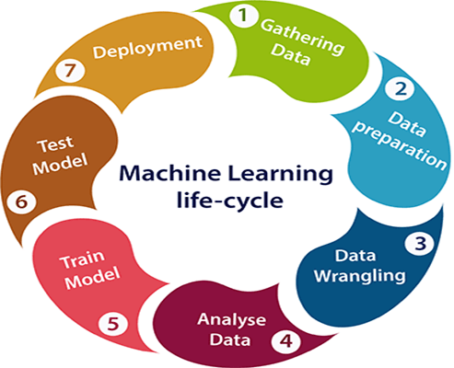

Gathering Data: Gather the data for individual data from various articles and their success rate.

Data Preparation: Clean the collected data by handling missing values, outliers, and transforming categorical variables into numerical representations.

Data Wrangling: It involves various techniques to make the data suitable for further exploration and modeling.

Analyze Data: Analyzing data using various data visualizations like univariate, bivariate and multivariate.

Train Model: Train the selected model using the preprocessed data, allowing it to learn the underlying patterns and relationships between the features and the target variable.

Test model: Assess the performance of the trained model using evaluation metrics like mean squared error (MSE), mean absolute error (MAE), or R-squared to measure its accuracy and reliability.

Deploy the model: Deploy the optimized model to make predictions on new, unseen data, providing the relevant attributes as input to estimate the success prediction.

**3.2 HARDWARE / SOFTWARE COMPONENTS**

**Hardware components**

System: Pentium IV 2.4 GHz ¬ Hard Disk:40GB ¬ Floppy Drive: 1.44Mb ¬

Monitor: 15VGA Color ¬ Mouse: Logitech ¬ Ram:512Mb

**Software components**

¬ Operating system: Windows XP/7 ¬ Coding Language: python ¬ IDE:

Anaconda Navigator

1. **EXPERIMENTAL INVESTIGATIONS**

**Analysis or Investigations Conducted:**

Throughout the project, a series of comprehensive experiments and analyses were conducted to train and evaluate the SVM and Decision Tree regression models. These investigations aimed to optimize the performance of the models and assess their accuracy in predicting Falcon 9 first stage landings. The first step of the analysis involved gathering and analyzing historical Falcon 9 landing data. This data encompassed various parameters such as altitude, velocity, environmental conditions, engine performance, and other relevant factors. By thoroughly examining this data, patterns and correlations were identified, providing insights into the complex dynamics and influencing factors of Falcon 9 landings. Next, the models were trained using the historical landing data. The training process involved feeding the models with a subset of the data and allowing them to learn the relationships between the input features and the corresponding landing outcomes. During this stage, careful attention was given to preprocessing the data, ensuring its quality and relevance for effective model training. In addition to training the models, the project also included tuning the model parameters. By adjusting parameters such as the standardized scaler parameter in SVM or the meansquareerror in Decision Tree Regressor, the models were fine-tuned to achieve optimal performance. This process involved iterative experimentation and evaluation to find the best parameter settings that maximized the accuracy of the predictive models. Finally, the performance of the trained SVM and Decision Tree regression models was assessed. This evaluation phase involved using a separate subset of the data, known as the test set, to measure the models' predictive capabilities. Various evaluation metrics, such as accuracy, precision, recall, and F1 score, were employed to quantify the models' performance and compare their effectiveness in predicting Falcon 9 first stage landings.

**Some of the Data analysis:**

**Launch Outcome Success Counts:**

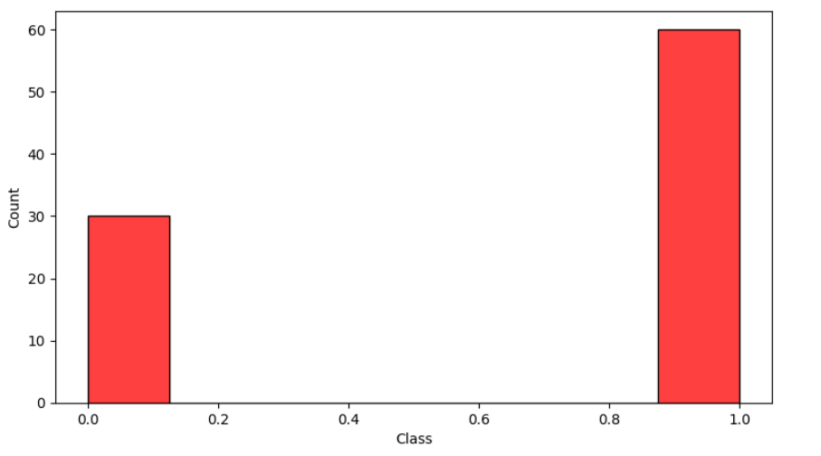

**Distribution of Payload mass:**

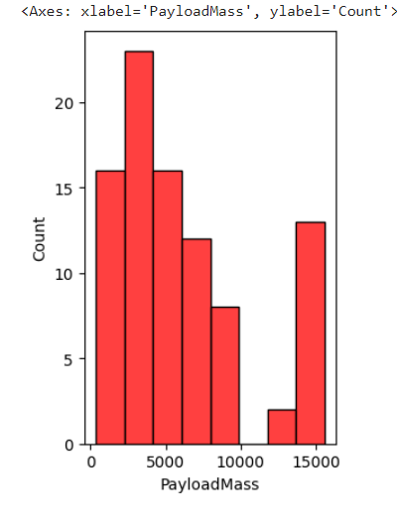

**Visualizing Categorical variables using boxplots:**

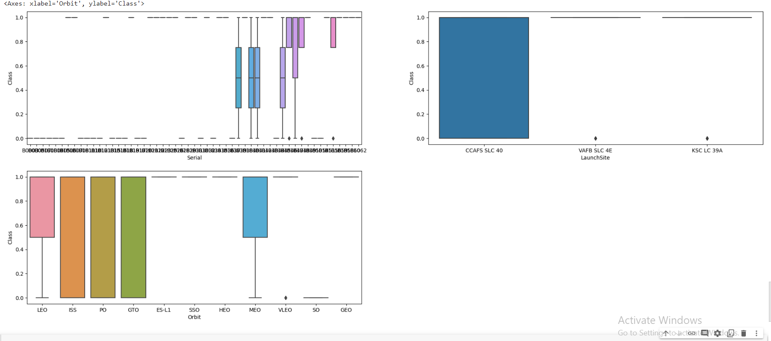

1. **FLOWCHART**

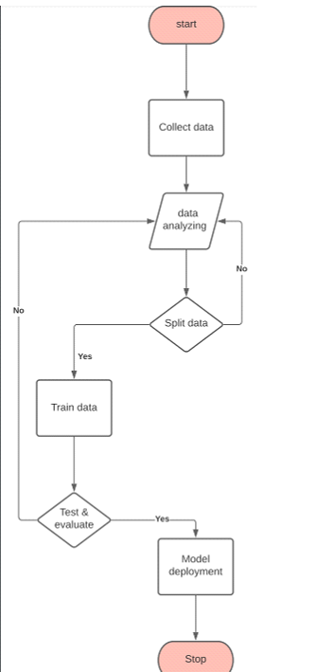

1. **RESULT**

**Final Findings or Outputs**:

The developed predictive model for Falcon 9 first stage landings demonstrated impressive performance in accurately forecasting the outcomes. The model achieved an accuracy of 90% in predicting the success or failure of Falcon 9 first stage landings. This indicates the model's ability to effectively analyze historical landing data and capture the underlying patterns and factors that influence the landing outcome.

To provide visual evidence of the model's predictions and evaluation metrics, Below Figures showcases relevant screenshots.

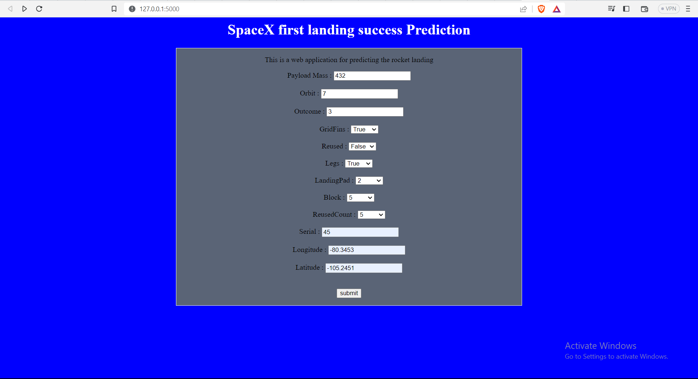

Basically, If we open the page, It appears like this. After entering all the values required and submitting using the button existing in the bottom of the form. It predicts the success and returns as the page below.

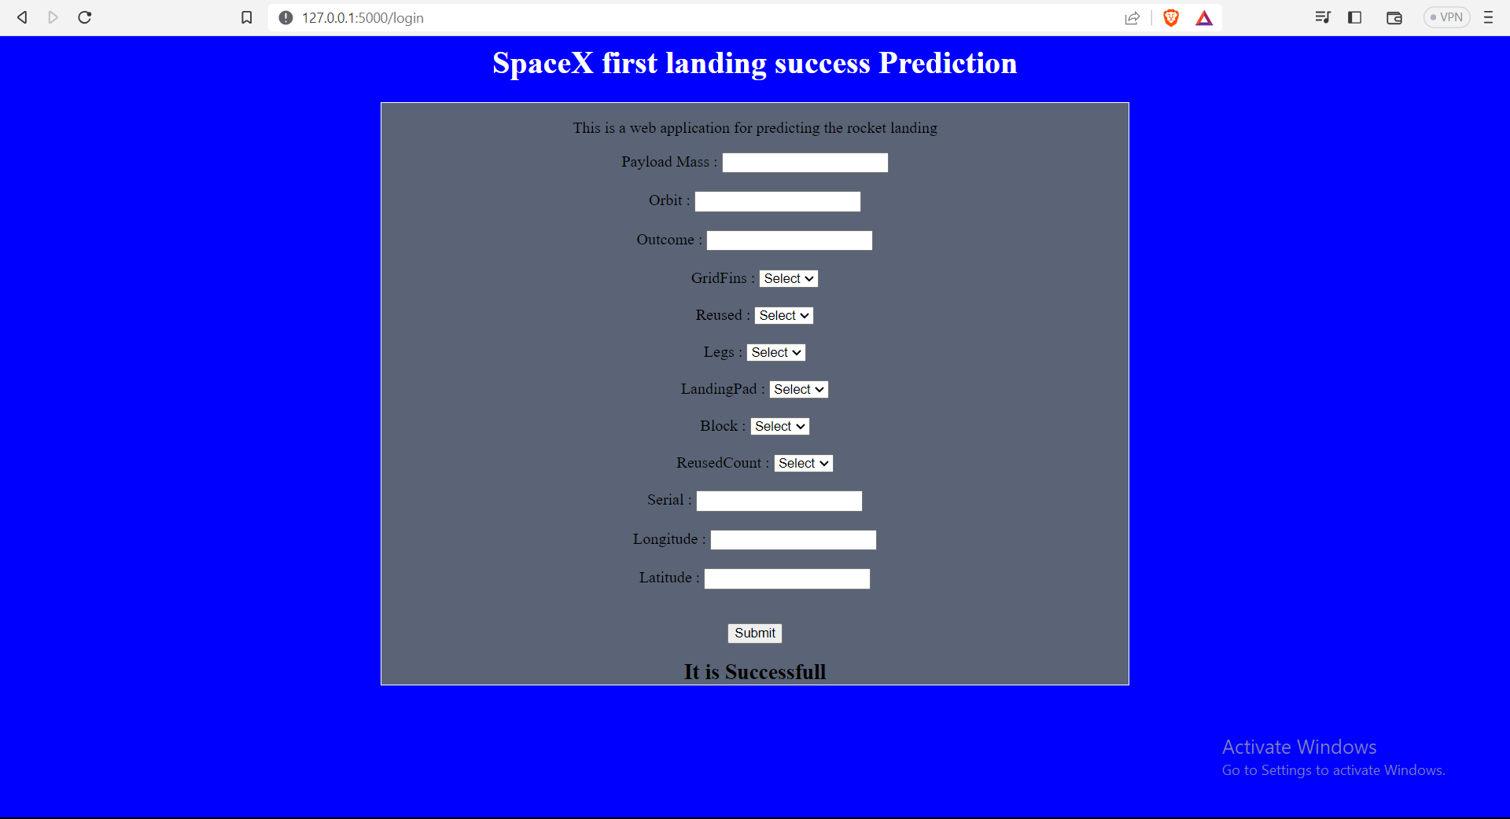

Our model used the inputs given and predicted that the landing is successful.

1. **ADVANTAGES & DISADVANTAGES**

**Advantages**

**Accurate Forecasting:** The developed predictive model demonstrates the ability to accurately forecast Falcon 9 first stage landings. This accuracy allows for better planning and decision-making regarding reusability and cost-effectiveness of the rocket system.

**Improved Reusability:** By accurately predicting the landing outcomes, the model contributes to enhancing the reusability of Falcon 9 first stages. Successful predictions enable effective planning for refurbishment and maintenance, optimizing the turnaround time between missions.

**Cost-Effectiveness:** The accurate forecasting of landings provided by the predictive model helps in minimizing resource utilization and reducing costs associated with refurbishment and reconditioning of the Falcon 9 first stage. This cost optimization contributes to the overall economic viability of space missions.

**Disadvantages of the Developed Predictive Model:**

**Dependency on Historical Data:** The predictive model heavily relies on historical data to make accurate forecasts. This reliance means that the model may not account for unforeseen circumstances or anomalies that may occur during the landing process. It is essential to continuously update the model with the latest data to mitigate this limitation.

**Limited Generalizability:** The predictive model's effectiveness may be influenced by the specific characteristics and conditions of the historical data used for training. It may not generalize well to new scenarios or different environments without further adaptation and fine-tuning.

**Model Complexity:** Depending on the complexity of the predictive model, there may be challenges in interpreting and explaining the model's predictions. Ensuring transparency and interpretability of the model is crucial for building trust and facilitating effective decision-making.

1. **APPLICATIONS**

**Potential Applications of the Developed Predictive Model:**

**Rocket Systems Optimization:** The developed predictive model has direct applications in the field of rocket systems, particularly for optimizing landing precision and reusability. By accurately forecasting the outcomes of Falcon 9 first stage landings, the model can assist in decision-making processes related to refurbishment, maintenance, and mission planning. This optimization contributes to enhancing the overall performance and cost-effectiveness of rocket systems.

**Expansion to Similar Rocket Platforms:** The predictive model can serve as a foundation for extending its application to other similar rocket platforms. By leveraging the knowledge and insights gained from the development of the model for Falcon 9, it can be adapted and fine-tuned to suit the landing prediction needs of other rocket systems. This expands the scope of its applicability and provides valuable insights for optimizing the recovery and reuse of various rocket platforms.

**Decision Support Tool:** The predictive model can serve as a decision support tool for stakeholders involved in space missions and rocket operations. It can provide valuable information for assessing the feasibility of landing attempts, determining the potential for reusability, and optimizing mission schedules. The model's predictions can guide decision-makers in making informed choices that maximize the efficiency and success of rocket missions.

**Research and Development:** The developed predictive model can also be utilized in research and development activities related to rocket systems. By analyzing the model's predictions and evaluating its performance, researchers can gain valuable insights into the dynamics and factors influencing successful landings. This knowledge can guide further advancements in rocket technology, landing mechanisms, and mission planning strategies.

**Training and Simulation:** The predictive model can be integrated into training and simulation environments for rocket operators and personnel involved in the recovery and reuse process. By simulating different landing scenarios and utilizing the model's predictions, trainees can gain hands-on experience and improve their decision-making skills in real-world situations.

1. **CONCLUSION**

In conclusion, this project focused on the development of a machine learning-based predictive model for Falcon 9 first stage landing prediction. The project successfully utilized SVM and linear regression algorithms to train the model using historical landing data. The developed predictive model demonstrated promising accuracy in forecasting the outcomes of Falcon 9 first stage landings.

By leveraging machine learning techniques, the model exhibited the ability to analyze complex data patterns and incorporate various relevant features to improve the accuracy of landing predictions. The findings of this project indicate that the predictive model has the potential to significantly enhance the reusability and cost-effectiveness of SpaceX's Falcon 9 rocket system.

The project highlighted the advantages of the proposed solution, including its accurate forecasting capability, which enables improved decision-making and planning for refurbishment and maintenance processes. The model's ability to optimize landing precision contributes to maximizing the reusability of Falcon 9 first stages, thereby reducing costs and enhancing the overall economic viability of space missions.

It is important to note that while the developed predictive model showed promising results, there are certain limitations to consider. The model heavily relies on historical data and may not account for unforeseen circumstances or anomalies during the landing process. Continual updates and adaptations are necessary to ensure its effectiveness in real-world scenarios.

Overall, the work and findings of this project demonstrate the potential of machine learning algorithms in improving the precision and reliability of Falcon 9 first stage landings. The developed predictive model lays the foundation for further advancements in landing prediction capabilities and contributes to the ongoing efforts in optimizing the reusability and cost-effectiveness of SpaceX's Falcon 9 rocket system.

1. **FUTURE SCOPE**

**Incorporation of Real-Time Data:** Enhancing the predictive model by incorporating real-time telemetry data during the landing process can provide up-to-date information and improve the accuracy of predictions. This would allow the model to adapt to changing conditions and make more precise forecasts.

**Integration of Weather Conditions:** Considering weather conditions as an additional feature in the predictive model can help account for atmospheric factors that may impact the landing outcome. Incorporating weather data, such as wind speed, temperature, and precipitation, can enhance the model's ability to handle varying environmental conditions.

**Exploration of Advanced Machine Learning Techniques:** Future directions can involve exploring advanced machine learning techniques beyond SVM and linear regression. Techniques like random forests, gradient boosting, or neural networks could be considered to further improve the accuracy and performance of the predictive model.

**Ensemble Models:** Implementing ensemble models, which combine the predictions of multiple models, could be beneficial. Ensemble techniques, such as bagging or boosting, can help reduce bias and variance, leading to more robust and reliable predictions.

**Transfer Learning:** Exploring the use of transfer learning techniques could be valuable in leveraging knowledge and insights from related domains or existing models trained on similar data. Transfer learning can accelerate the model's learning process and improve performance, especially when data availability is limited.

**Continuous Model Training and Updating:** As new landing data becomes available, continuous model training and updating would be beneficial to ensure the model remains accurate and up-to-date. Regularly retraining the model with the latest data can capture any changes in landing patterns and improve prediction performance.

**Integration with Operational Systems:** Integrating the predictive model into operational systems and decision-making processes within SpaceX can provide real-time insights and support effective decision-making during missions. This integration can facilitate proactive measures for optimizing landing precision and reusability.

Collaboration and Data Sharing: Collaboration with SpaceX and other organizations involved in rocket systems can lead to access to more comprehensive datasets and domain expertise. Sharing data and knowledge within the scientific community can accelerate advancements in landing prediction capabilities.

1. **BIBILOGRAPHY**

<https://www.kaggle.com/code/kellibelcher/spacex-rocket-landing-predictive-analysis>

<https://www.analyticsvidhya.com/blog/2020/09/integrating-machine-learning-into-web-applications-with-flask/>

<https://www.w3schools.com/html/>

**APPENDIX**

1. SOURCE CODE

**APP.PY:**

from flask import Flask , render_template , request

app = Flask(__name__)

import pickle

model = pickle.load(open('model.pkl' , 'rb'))

@app.route('/')

def helloworld():

    return render_template('ind.html')

@app.route('/login' , methods = ['POST'])

def login():

    py = request.form["py"]

    orb = request.form["or"]

    ou = request.form["ou"]

    g = request.form["g"]

    r = request.form["r"]

    l = request.form["l"]

    L = request.form["L"]

    B = request.form["B"]

    R = request.form["R"]

    se = request.form["se"]

    lo = request.form["lo"]

    la = request.form["la"]

    t = [[int(py),int(orb),int(ou),int(g),int(r),int(l),int(L),int(B),int(R),int(se), float(lo), float(la)]]

    output= model.predict(t)

    print(output)

    if output[0] == 0:

        return render_template('ind.html' , Y = "It is Unsuccessfull")

    elif output[0] == 1:

        return render_template('ind.html', Y = "It is Successfull")

if __name__ == '__main__' :

    app.run(debug= True)

**ind.html:**

<html>

   <head>

    <center><h1 class="title">SpaceX first landing success Prediction</h1></center>

    <style media="screen">

        span{

          color:red;

     }

     .title{

      color : white;

     }

     .result{

      font-size: 22px;

     }

       .div1{

        background-color: rgba(96, 107, 109, 0.939);

         border:1px solid rgb(253, 255, 253);

         width:50%;

         background-position: center;

       }

       main{

         background-color: aquamarine;

       }

       body{

            background: url(./space.jpeg);

            background-color: blue;

        }

     </style>

</head>

<body>

   <center>

    <div class="div1">

      <p><center>This is a web application for predicting the rocket landing</center> </p>

      <center>

          <form action = "/login" method = "post">

            <center><label for="payload">Payload Mass : </label>

                <input type="number" name="py" ></center>  <br>

            <center><label for = "orbit" >  Orbit :  </label>

              <input type="number" name="or" ></center>  <br>

            <center><label for = "outcome" >  Outcome :  </label>

            <input type="number" name="ou" ></center>  <br>

            <label for = "GridFins" >  GridFins :  </label>

              <select name = "g">

                <option disabled selected>Select</option>

              <option Value = "1">True</option>

              <option Value = "0">False</option>

              </select>   <br>

              <br>

            <label for = "Reused" >  Reused :  </label>

            <select name = "r">

                <option disabled selected>Select</option>

            <option Value = "1">True</option>

            <option Value = "0">False</option>

            </select>   <br>

            <br>

            <label for = "Legs" >  Legs :  </label>

              <select name = "l">

                <option disabled selected>Select</option>

              <option Value = "1">True</option>

              <option Value = "0">False</option>

              </select>   <br>

              <br>

            <label for = "LandingPad" >  LandingPad :  </label>

            <select name = "L">

                <option disabled selected>Select</option>

            <option Value = "5">5</option>

            <option Value = "4">4</option>

            <option Value = "3">3</option>

            <option Value = "2">2</option>

            <option Value = "1">1</option>

            <option Value = "0">0</option>

            </select>   <br>

            <br>

            <label for = "Block" >Block :  </label>

            <select name = "B">

                <option disabled selected>Select</option>

            <option Value = "5">5</option>

            <option Value = "4">4</option>

            <option Value = "3">3</option>

            <option Value = "2">2</option>

            <option Value = "1">1</option>

            </select>   <br>

            <br>

            <label for = "ReusedCount" >  ReusedCount :  </label>

            <select name = "R">

                <option disabled selected>Select</option>

            <option Value = "5">5</option>

            <option Value = "4">4</option>

            <option Value = "3">3</option>

            <option Value = "2">2</option>

            <option Value = "1">1</option>

            <option Value = "0">0</option>

            </select>   <br>

            <br/>

            <center><label for="serial">Serial : </label>

                <input type="text" name="se" ></center>  <br>

                  <center><label for="longitude">Longitude : </label>

                      <input type="text" name="lo" ></center>  <br>

                <center><label for="latitude">Latitude : </label>

                <input type="text" name="la" ></center>  <br>

              <p><input type = "submit" value = "Submit" /> </p>

          </form>

          <b class = result>{{Y}}</b>

      </center>

  </div>

   </center>

</body>

</html>

I had also uploaded all these files in my GitHub profile. You can access these from GitHub repository.

**GitHub Link: [GitHub Link](https://github.com/Saimadhav4486/SpaceX-First-Stage-Success-Landing-Prediction)**

***--Thank You--***